

Dr. Dylan, Wilson inc.

2018-08-05

Dr. Wilson

10995 Le Forge, Port Theresaburgh, PR 13543

Phone: 507200972

Fax: 9426937556

**Re:** Shelley, Jackson

**PHN:** 837167636

**Birthdate:** 17-May-1938

**Address:** 432 Diane Lodge Suite 699, Port Christopher, FL 44092

**Patient number:** 2285999109

To Whom It May Concern:

This is a medical letter to state the above patient is pregnant with expected delivery date of 28-Oct-2025. Hoping this information is satisfactory for your requirements.

Thank you.

Sincerely,

Dr. Dylan, Wilson

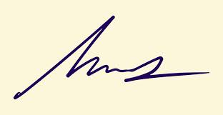

FRCS© NCMP

Clinical Assistant Professor, UBC

Department of Obstetrics and Gynecology SMH